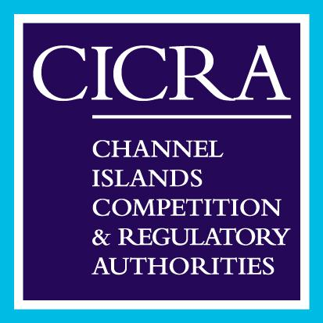

NEWS RELEASE
Date 19 November
Guernsey to host the first public Channel Island 5G Summit
Government officials, senior telecom industry and digital sector leaders, and experts from the UK will come together in Guernsey later this month at an event organised by the pan Channel Islands telecoms regulator CICRA, to discuss and debate opportunities for the Channel Islands as the advent of 5G technology draws nearer.

The Channel Islands are already well served with reliable and resilient telecommunications services, however over the next few years mobile technology will take another leap forward with the introduction of 5G.

With estimates that 5G could account for as many as 1.4 billion connections and networks covering one third of the world’s population by 2025, the global impact of this new technology will be profound.

5G is more than a new generation of technologies; it denotes a new era in which connectivity will become increasingly fluid and flexible. 5G networks will adapt to applications and performance will be tailored precisely to the needs of the user.

CICRA has worked closely with all stakeholders to put together the 5G Summit, which is being held at the St Pierre Park Hotel on Monday 26 November. The day long event will consider up-to-date information and the benefits 5G could deliver for the Islands, which are well placed to take advantage of this new technology, enhancing our digital sectors, and potentially providing new jobs and revenues.

Nemanja Vucevic from the Global Management Consultancy McKinsey will provide the key note speech, providing stakeholders with an understanding of what development is taking place around the world with 5G and how this will benefit the Islands over the next 5 years. Both governments will outline their telecoms strategies and policies and how these will align with the implementation of 5G and how important it will be for the economies as a whole. There will also be presentations and panel discussions with CICRA, local telecoms operators, the UK telecoms regulator Ofcom, Digital Jersey and the Digital Greenhouse Guernsey.

CICRA has also been working with school children in both Islands to ensure their views are considered. School representatives from both Islands will share their thoughts and ideas about 5G and some of the challenges and opportunities it will provide them.

CICRA has already made significant progress in developing the regulatory framework that will support the introduction of 5G, working with Ofcom in the UK to ensure innovation/trial spectrum (radio frequencies) and licenses are now available locally, allowing operators to test new applications and services on Island ahead of a full roll out of the technology.

The 5G Summit will provide everyone with the opportunity to find out more information about 5G, the operators’ plans for network roll out and new services, along with a clear framework from CICRA regarding the licenses and spectrum allocation process.

Colin Vaudin Chief Information Officer, States of Guernsey said, “We have a clear policy to support the latest 5G technology and it is our intention to provide the right incentives for operators to implement this within the next 2 years, this will place Guernsey at the forefront of this technology in Europe and provide local consumers, businesses and government the opportunity to develop new innovative solutions, creating new jobs and making high speed internet access available to everyone”.

Stephanie Peat Director of Digital and Telecoms Policy, States of Jersey said, “Jersey is fortunate to be well-served with an excellent digital infrastructure that includes a full-fibre to the home network and three 4G networks. Our telecoms strategy sets out our plans to maximise the benefits of this infrastructure and is also very clear about Jersey’s commitment to remaining at the forefront of innovation to support our digital sector and wider economy”

Tim Ringsdore, Director at the Channel Islands Competition and Regulatory Authorities said: “We are extremely excited about the 5G Summit as we have been working very closely with all stakeholders to get to a point where we can share industry views regarding the value this technology will bring to the Islands over the next 5 years. It is our intention to create a regulatory framework that encourages investment and provides the best value communication solutions for all consumers in the Channel Islands”.
ENDS

NOTES TO EDITORS:
Issued by ORCHID
Allan Watts
T: 01534 888994 E: allan@orchid.je

For more information contact Tim Ringsdore
T: 01534 514987 E: tim.ringsdore@cicra.je

About The Channel Islands Competition and Regulatory Authorities:
The Channel Islands Competition and Regulatory Authorities is the name given to the Jersey Competition Regulatory Authority (JCRA) and the Guernsey Competition and Regulatory Authority (GCRA) (formerly the Office of Utility Regulation). The JCRA was established under the Competition Regulatory Authority (Jersey) Law, 2001, and the GCRA was established under The Guernsey Competition and Regulatory Authority Ordinance, 2012. In Jersey, the telecoms and postal sectors are regulated by the JCRA, which is also responsible for administering and enforcing the Competition (Jersey) Law 2005. In Guernsey the telecoms, postal and electricity sectors are regulated by the GCRA, which is also responsible for the administration and enforcement of the Guernsey competition law since it came into force on 1 August 2012.
By working together and sharing resources and expertise between the islands, CICRA strives to ensure that consumers in all the Channel Islands receive best value, choice and access to high quality services.

